Challenge 1:

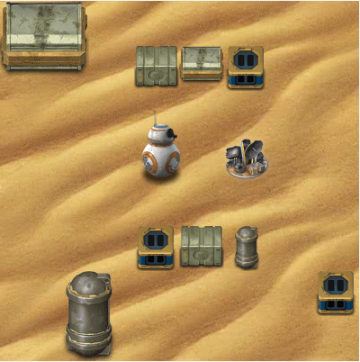

Solution:

Blocks:

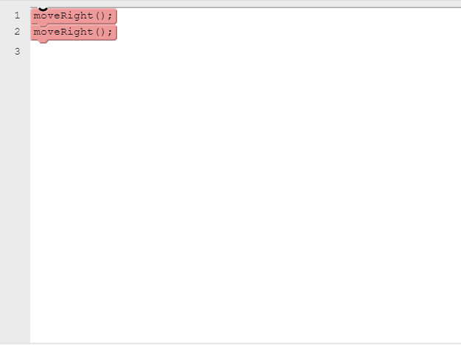

Java Codes:

moveRight();

moveRight();